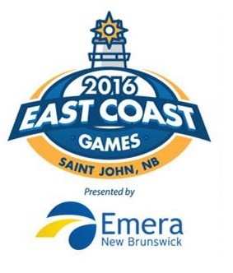 | EAST COAST GAMES  Saint John, NB  June 21-23rd, 2019

Team Registration Form

Women’s Divisions: | □ U14 (or weaker U15) | □ U16 (or weaker U17)
Men’s Divisions: | □ U14 (or weaker U15) | □ U16 (or weaker U17)

Province:
Team Name:

# | Player’s Name | Position | T-Shirt Size

Coaches Name | Email | Size | Phone #

2019 EAST COAST GAMES BASKETBALL will be hosted at UNBSJ in Saint John. More information will be posted on the website at http://www.eastcoastgames.ca/sports/basketball/

Registration form and $500 payment must be received by May 30th, 2019.

Form should be emailed to: vincentp@nbnet.nb.ca so info can be included in the program.
Please Mail Checks to: (Made out to) East Coast Games Basketball
Peter Vincent, 8 Rivercrest Drive, Quispamsis, NB, E2E1W4

For more information contact:
Peter Vincent
Home Phone: 506-849-3933, or Cell: 506-650-0875 |coachpbv@gmail.com

www.EastCoastGames.ca

