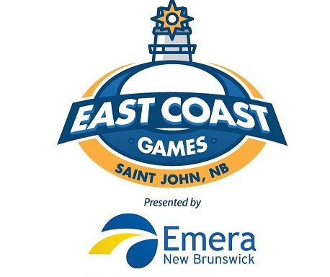
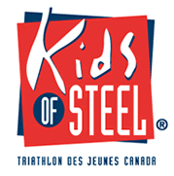
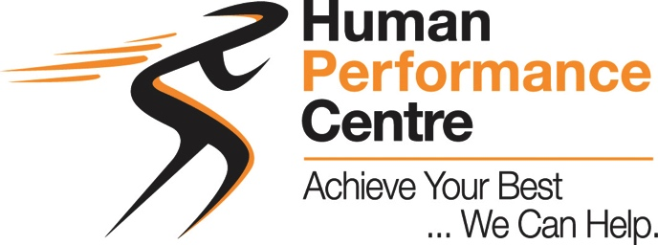

TRINB Swim• Bike •Run

Saturday - JUNE 22, 2019
Rockwood Park Fisher Lakes
7:45 AM Pre-event briefing

Please register online at www.ccnbikes.com and search for “Rockwood Park Kids of Steel”
Fax using this form to 506-738-2824
COST $19/child or $36/family until 15 June
COST $22 /child or $43/family from16- 21June
Age Division (Swim / Bike / Run)

6-7 (born 2012 -2013) 25m/1.5km/400m
8-9 (born 2010-2011) 50m/3km/1km
10-11(born 2008-2009) 100m/4.5km/ 2km
12-13(born 2006-2007) 150m/6km/ 3km
14-15 (born 2004-2005) 200m/7.5km/ 3km
*Distances may vary slightly for safety
EVENT DAY COST $30/child

For more info go to hpcphysio.com/kidsofsteel.php

Further questions? Contact gina.spearburrows@gmail.com

- - - - - - - - - - - - - - - - - - - - - - - - - - - - - - - - - - - - - - - - - -- - - - - - - - - - - - - - - -
REGISTRATION FORM
NAME OF PARTICIPANT: _____________________________
AGE OF PARTICIPANT Dec 2019: ______
DATE OF BIRTH: _________________________
PARENT AUTHORIZATION: ________________________________
PHONE#: ______________________
EMAIL ADDRESS: _____________________________

